**Product Name:** MuscleMinder

**Team Name:** FitTech Innovators

**Date:** 5/8/2024

# Sprint 2 Report

## Work Completed

This sprint was centered on user story 2.1 worth 13 points. We were able to finish tasks 2.1.1-6 which were concerned with setting up a database and connecting it to a backend. We were not able to fully finish connecting the frontend to the backend. Therefore we have not fully completed the user story and will need to finish it at the start of the next sprint.

## Work Rate

25.5 ideal work hours were spent on this sprint which is 1.82 hours per day. We completed 10 story points, short of the planned 13, at a rate of 0.71 story points per day.

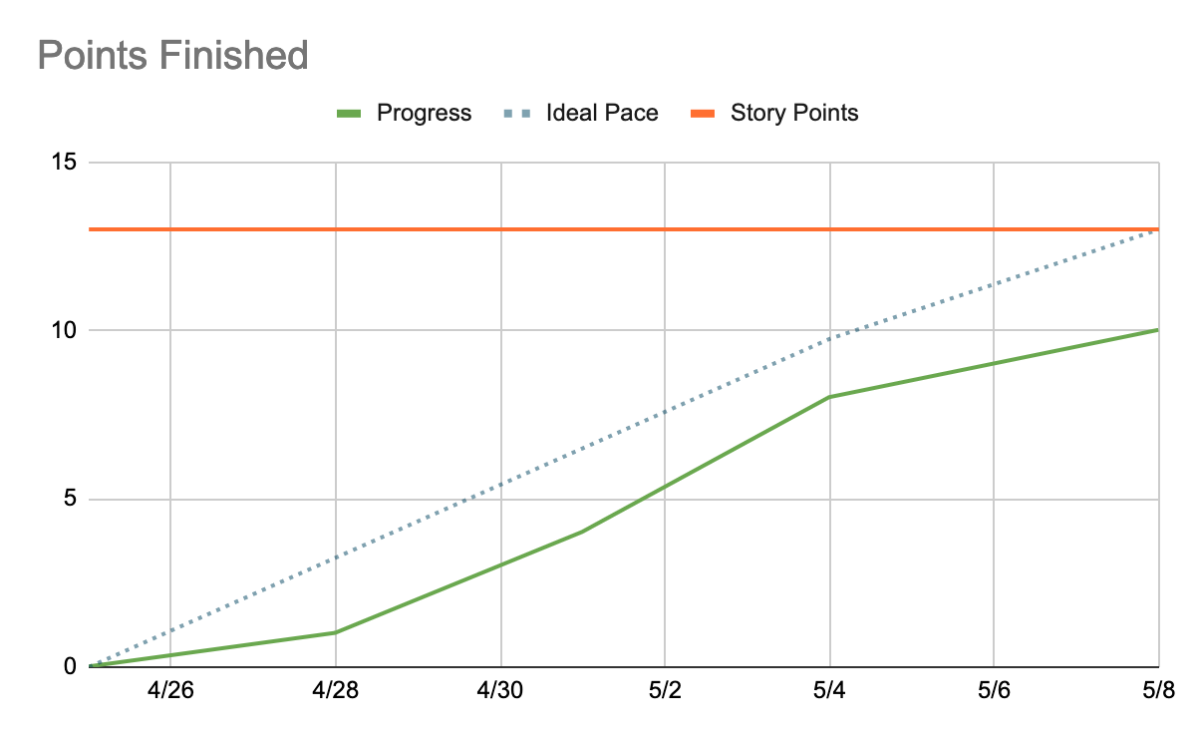

Overall through 2 sprints, we have finished 28 story points at roughly 1 story point a day. This has taken 52.5 ideal work hours at 1.87 hours a day.

## Actions to Stop Doing

The team should stop having long periods of no communication and be more consistent about scheduling and attending scrum meetings. Scrum meetings should be scheduled much further in advance, spaced out through the week, and team members should make an effort to have a more available schedule. This was a problem in sprint 1 as well, and we will need to hold each other accountable to ensure the second half of development goes smoothly.

## Actions to Continue

The team should continue to distribute and contribute towards tasks based on their technical knowledge. A large barrier last sprint was unfamiliarity with the tech stack, a problem which should be resolved by now. The team should also continue to update each other on the progress of their tasks through discord.

## Actions to Start Doing

The team struggled to communicate the last two sprints so scrum meetings should be scheduled and team members should commit to showing up and communicating. The first week of meetings has been planned and the team should continue to do so through the rest of the development period in coordination with the TA who is holding us responsible. The team should also try to get more tasks done earlier in the sprint to allow ample time for testing and resolving issues/conflicts that arise.